**EXPERIMENT NO:7**

**FCFS SCHEDULING ALGORITHM:**

#include <stdio.h>

int main()

{

int pid[15];

int bt[15];

int n;

printf("Enter the number of processes: ");

scanf("%d",&n);

printf("Enter process id of all the processes: ");

for(int i=0;i<n;i++)

{

scanf("%d",&pid[i]);

}

printf("Enter burst time of all the processes: ");

for(int i=0;i<n;i++)

{

scanf("%d",&bt[i]);

}

int i, wt[n];

wt[0]=0;

for(i=1; i<n; i++)

{

wt[i]= bt[i-1]+ wt[i-1];

}

printf("Process ID Burst Time Waiting Time TurnAround Time\n");

float twt=0.0;

float tat= 0.0;

for(i=0; i<n; i++)

{

printf("%d\t\t", pid[i]);

printf("%d\t\t", bt[i]);

printf("%d\t\t", wt[i]);

printf("%d\t\t", bt[i]+wt[i]);

printf("\n");

twt += wt[i];

tat += (wt[i]+bt[i]);

}

float att,awt;

awt = twt/n;

att = tat/n;

printf("Avg. waiting time= %f\n",awt);

printf("Avg. turnaround time= %f",att);

}

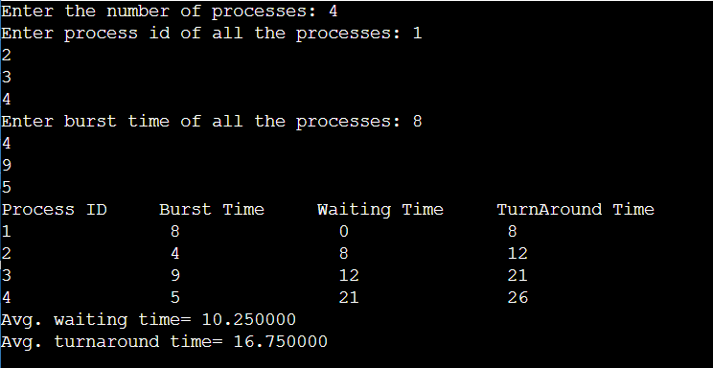

**Shortest job first:**

#include<stdio.h>

int main()

{

int bt[20],p[20],wt[20],tat[20],i,j,n,total=0,totalT=0,pos,temp;

float avg_wt,avg_tat;

printf("Enter number of process:");

scanf("%d",&n);

printf("\nEnter Burst Time:\n");

for(i=0;i<n;i++)

{

printf("p%d:",i+1);

scanf("%d",&bt[i]);

p[i]=i+1;

}

for(i=0;i<n;i++)

{

pos=i;

for(j=i+1;j<n;j++)

{

if(bt[j]<bt[pos])

pos=j;

}

temp=bt[i];

bt[i]=bt[pos];

bt[pos]=temp;

temp=p[i];

p[i]=p[pos];

p[pos]=temp;

}

wt[0]=0;

for(i=1;i<n;i++)

{

wt[i]=0;

for(j=0;j<i;j++)

wt[i]+=bt[j];

total+=wt[i];

}

//average waiting time

avg_wt=(float)total/n;

printf("\nProcess\t Burst Time \tWaiting Time\tTurnaround Time");

for(i=0;i<n;i++)

{

tat[i]=bt[i]+wt[i];

totalT+=tat[i];

printf("\np%d\t\t %d\t\t %d\t\t\t%d",p[i],bt[i],wt[i],tat[i]);

}

avg_tat=(float)totalT/n;

printf("\n\nAverage Waiting Time=%f",avg_wt);

printf("\nAverage Turnaround Time=%f",avg_tat);

}

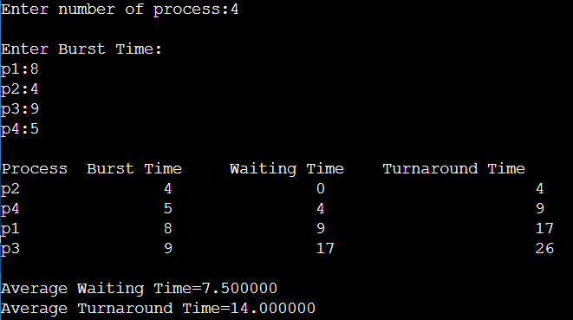

**Round robin:**

#include<stdio.h>

#include<conio.h>

**void** main()

{

**int** i, NOP, sum=0,count=0, y, quant, wt=0, tat=0, at[10], bt[10], temp[10];

**float** avg_wt, avg_tat;

    printf(" Total number of process in the system: ");

    scanf("%d", &NOP);

    y = NOP;

**for**(i=0; i<NOP; i++)

{

printf("\n Enter the Arrival and Burst time of the Process[%d]\n", i+1);

printf(" Arrival time is: \t");

scanf("%d", &at[i]);

printf(" \nBurst time is: \t");

scanf("%d", &bt[i]);

temp[i] = bt[i];

}

printf("Enter the Time Quantum for the process: \t");

scanf("%d", &quant);

printf("\n Process No \t\t Burst Time \t\t TAT \t\t Waiting Time ");

**for**(sum=0, i = 0; y!=0; )

{

**if**(temp[i] <= quant && temp[i] > 0)

{

    sum = sum + temp[i];

    temp[i] = 0;

    count=1;

    }

**else** **if**(temp[i] > 0)

    {

        temp[i] = temp[i] - quant;

        sum = sum + quant;

    }

**if**(temp[i]==0 && count==1)

    {

        y--;

        printf("\nProcess No[%d] \t\t %d\t\t\t\t %d\t\t\t %d", i+1, bt[i], sum-at[i], sumat[i]-bt[i]);

        wt = wt+sum-at[i]-bt[i];

        tat = tat+sum-at[i];

        count =0;

    }

**if**(i==NOP-1)

    {

        i=0;

    }

**else** **if**(at[i+1]<=sum)

    {

        i++;

    }

**else**

    {

        i=0;

    }

}

avg_wt = wt * 1.0/NOP;

avg_tat = tat * 1.0/NOP;

printf("\n Average Turn Around Time: \t%f", avg_wt);

printf("\n Average Waiting Time: \t%f", avg_tat);

getch();

}

